**Movie-related data**

All datasets containing:

* Movie name, movie id, date
* Many user rate/review 1 movie

1. The mother of all movies review: <https://www.kaggle.com/datasets/bwandowando/rotten-tomatoes-9800-movie-critic-and-user-reviews>

* Movies.csv: movieID, movie name, url, date, ...
* User_reviews.csv: userID, movieID, rating, review content, ...

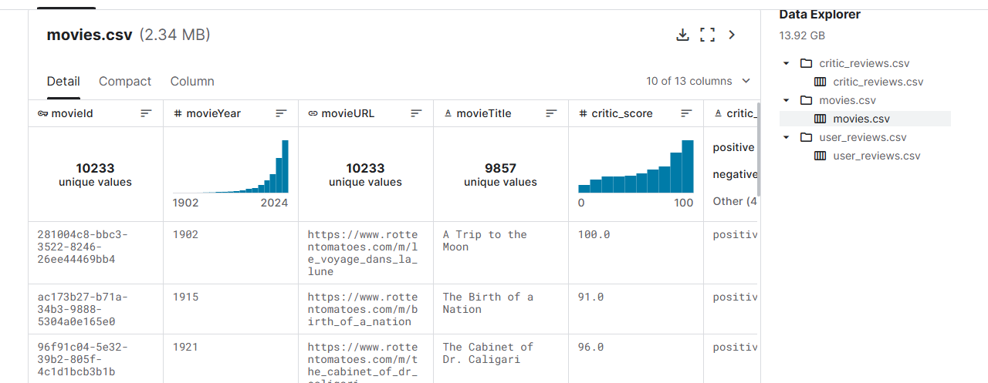

1. MUBI SVOD Platform Database for Movie Lovers: <https://www.kaggle.com/datasets/clementmsika/mubi-sqlite-database-for-movie-lovers?select=mubi_ratings_data.csv>

1. IMDb Review Dataset – ebD: <https://www.kaggle.com/datasets/ebiswas/imdb-review-dataset?select=part-02.json>

